**Exam 2 Topics Review**

**Questions:**

1. Explain the basic concept of the F-ratio.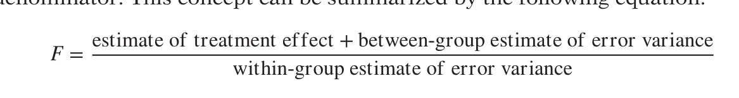
   1. Why do you need two different degrees of freedom to describe it?

The F distribution is a ratio of two distributions generated from MSbet and MSW. The distribution changes shape depending on the degrees of freedom for each group; one from the total number of groups being compared (MSbet) and the other from the total number of subjects in all groups combined (MSW).

* 1. Explain the numerator and denominator.

The numerator represents the variance between the groups (MSbet), plus the between groups error variance and the denominator represents the variance within the groups (MSw). That way when you calculate it out, you’re getting the variance of the groups/conditions while controlling for the variance that exists naturally within the groups and error.

* 1. Explain a scenario when F < 1 and describe in words what this means.

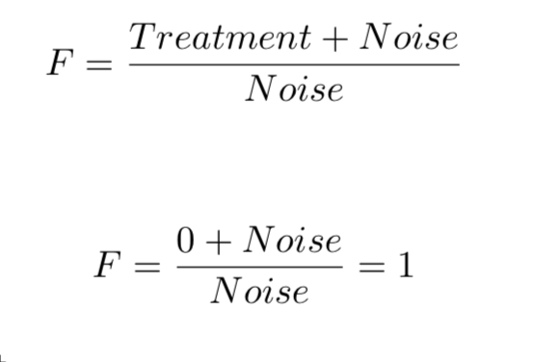

An F ratio greater than 1 indicates that the sample means are further apart than what would be expected by chance and the treatment caused more of a difference than just error. An F ratio less than 1 indicates that the sample means are closer together than could be expected by chance and there is more noise than there is effect.

1. Explain how the F distribution is derived.

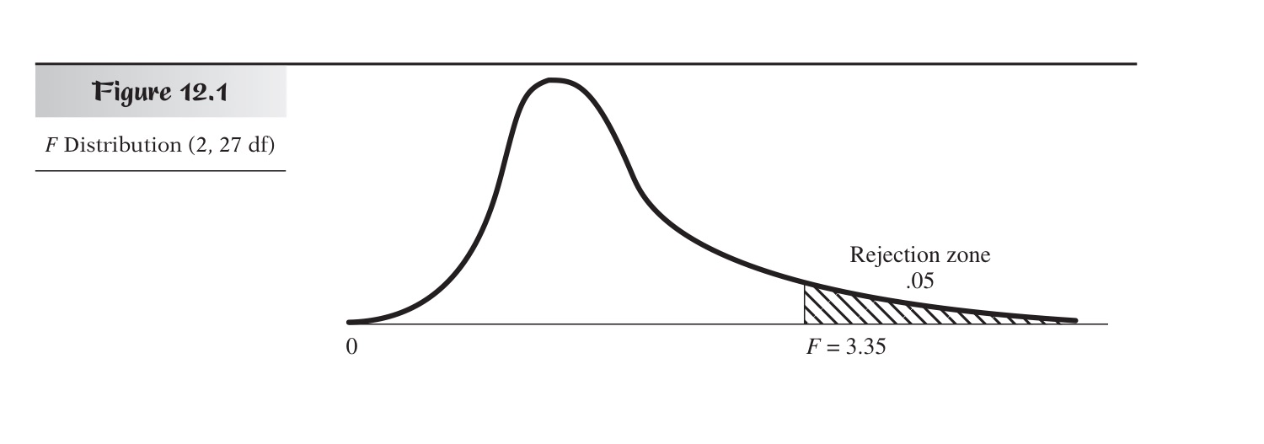

* 1. Why is it a one tailed?

The F ratio is one tailed because it represents situations where all of the sample means are close together (near 0) versus spread apart (greater than 1). It’s a ratio of two variances and variances can never be negative so the only direction it can move is positive.

* 1. How does it change relative the different DFs?

As the sample size increases, the F distribution becomes less skewed. As dfw approaches infinity the F distribution becomes indistinguishable from a normal distribution with a mean of 1.

* + 1. Which DF impacts the critical values more and why?

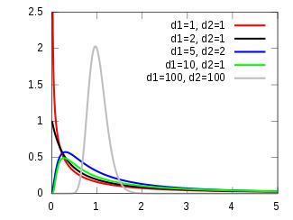

dfw: If the number of subjects in the groups increases, the critical value decreases

dfb: If the number of groups increases, the critical value increases

The denominator is more important because having a large sample size impacts your power/ability to measure things reliably (dfw)

* 1. Why when DFn = ∞ & DFd = ∞, the critical value is 1?

When there is no difference between the group means, the F is 0

If the F is 1 is means that the variance within the group and between groups are equal; you’re no longer measuring a sample, you’re measuring the population and any difference in the means is significant because you have the entire population

1. Explain the logic of the ANOVA.

ANOVA takes multiple groups with the same IV and tests whether there is a difference in variance between groups.

* 1. What are the benefits and disadvantages of ANOVA logic?

Benefits: Reduces the chance of making Type 1 error, compared to doing multiple t tests. ANOVA can find a significant difference among several group means. even when no two of the means are significantly different from one another

Disadvantages: You have to do additional tests to know which groups are different from one another.

* + 1. Why can’t we just do a bunch of t-tests when we have multiple groups to compare?

That would increase the chance of making Type 1 error – The possibility of having Type 1 error is always present, but when you do multiple tests it compounds

* 1. What are the assumptions of the ANOVA?

Homogeneity of variance (HOV): that the variance within each of the groups is the same in all groups

Normality

* + 1. How do we test for them?

Homogeneity of variance (HOV): We test for this using the Brown-Forsythe formula, which subtracts the median within each cell and recalculates the ANOVA. If the cells are homogenous, the values should all equal zero.

Normality: To test whether the data are normal, you can plot the sample quartiles by their theoretical quartiles and should see a linear relationship (qqplot). If it doesn’t fit the line then you know it is skewed.

* + 1. How do we adjust for them if they are violated?

You can’t! And all violations increase type 1 error

* 1. Explain what types of experimental factors can impact the MSerror terms.

Experimenter error, confounds, bias, single-blinded vs double-blinded

* 1. What is the null and alternative hypothesis for a one-way ANOVA

Null = no significantly different variance between groups

Alternative = some significantly different variance between groups

* 1. Explain the logic of the ANOVA Source Table

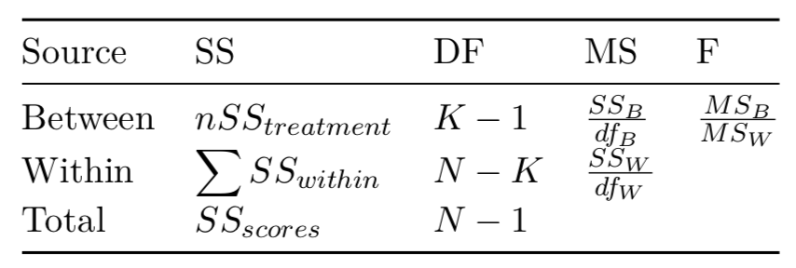

You can use the source table to logic through the info that you have to calculate the missing values or the F

* + 1. Explain where each formula in the table comes from:
       1. What does each represent?
       2. How do the cells in the table relate to each other?
  1. Explain the different effect sizes measurements

Eta squared and omega: used to explain the population variance

* + 1. Explain what each one means and how to interpret them

Eta squared: the size of effect attributed to the treatment; usually an overestimation of the effect size

Omega: correction for eta; takes into account MSw

* + 1. How does eta-squared differ from omega squared?

Omega is slightly more conservative because it takes into account MSw

1. What are contrasts?

Contrasts are designations made for groupings of variables created to conduct tests. Mathematically, they’re coefficients multiplied with the variable to give it weight (or you can remove a variable by multiplying by 0).

* 1. What are planned contrasts and when do you use them?

Planned contrasts are contrasts made for post hoc confirmatory testing. You would do this if your ANOVA was significant and you needed to know which groups were significantly different from one another.

* + 1. Explain what protected t-tests are and what is ‘protected’ and how?

Protected t tests are used to test group means after a significant ANOVA has been obtained. You must first have a significant ANOVA in order to keep down Type 1 error. A slightly modified t test formula is used where the critical t is based on dfw rather than the df for just the two groups involved in the t test. This is preferred because dfw is larger than df, leading to a small critical t, making it more difficult to reach significance and further avoiding the possibility of committing Type 1 error.

* 1. What are unplanned contrasts and when do you use them?

Unplanned are exploratory tests

* + 1. Explain the different types of post-hoc tests

LSD – “Least Significant Difference”; least conservative test, provides almost no protection from type 1 error; would only be appropriate for confirmatory tests with 3 or less comparisons

HSD – “Honestly Significant Difference”; protects against type 1 error better than LSD;

slightly more conservative than LSD;

Sidak – takes to Bonferroni and adjusts the alpha so that it isn’t quite as conservative; can be used when doing more than 3 unplanned tests

Bonferroni – super extremely conservative and sucks up all your power; likely will not detect an effect

* + - 1. Under which situations would you use one over the other?

Unplanned need more conservative corrections, also conservatism depends on the number of tests you run

* + - * 1. What the strength and weakness of each?

Some are more or less conservative

* 1. What are the proper errors terms for each type of contrast

Some use MSw and some use MScontrast

* 1. What are the dangers of multiple comparisons?

Inflated chance of committing Type 1 error

* + 1. Explain Familywise/Experimentwise error

FWE alpha = the probability that an experiment will produce any Type 1 errors

FWE would be large for conducting multiple t tests and reduced for an ANOVA

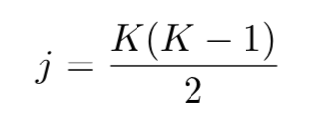

J is the number of comparisons being made. If there is an ANOVA with 6 groups, 15 comparisons are being made. If all 15 were t tests or were conducted post hoc there would be a very large chance of committing type 1 error/high FWE. This means we would be more likely to fail to reject the hypothesis, even though the effect isn’t real.

**What you should be able to do:**

1. Calculate a one-way and two-way ANOVA
2. Be able to select and implement the proper follow up tests given your hypotheses.
3. Be able to unpack an interaction in complex studies.
4. Explain the results of the ANOVA and follow-up tests in APA format.
5. Explain what violating the assumptions of the ANOVA might mean for your results and how to correct for those violations.

Nil hypothesis – you change the h0 from 0 to whatever the universe’s base rate is. Like things in general are weakly correlated, so you shouldn’t test correlation versus no correlation, you should test R2=0.7 versus something higher